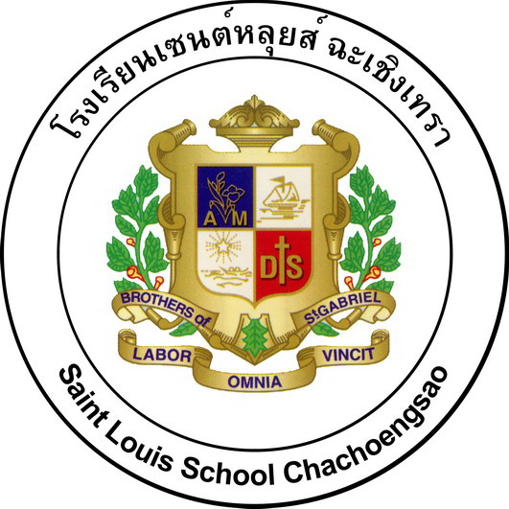
Lesson Plan

Subject________________ Level_____ Semester__ Academic Year_____

Unit_____ Topic/Theme__________________________ For____ Periods
*************************************************************

1. Learning Outcome

2. Main Concept (Concept Mapping)

Sub-Concept 1

Sub-Concept 2

Main Concept

By which methodologies
- Reading
- Listening

Desirable Characteristics

Sub-Concept 3

Sub-Concept 4

3. Sub-Concept and Topic
3.1
3.2
3.3
3.4
3.5

4. Learners’ Key Competencies

5. Desirable Characteristics

6. Learning Objectives
Knowledge
1.____________________________________________________________
2.____________________________________________________________
Competencies
3.____________________________________________________________
4.____________________________________________________________
Desirable Characteristics
5.____________________________________________________________
6.____________________________________________________________

7. Learning Activities

8. Materials
1.
2.

9. Evaluation Tools
1.
2.

10. Evaluation Procedures

Learning Objectives | Evaluation Procedures | Evaluation Tools | References | Criteria
1.
2.
3.
4.

11. Teacher’s Notes

11.1 Deep Knowledge
__________________________________________________________________________________________________________________________

11.2 Competencies
__________________________________________________________________________________________________________________________

11.3 Desirable Characteristics
__________________________________________________________________________________________________________________________

11.4 What is needed to improve your students?
__________________________________________________________________________________________________________________________

11.5 What is needed to improve on your teaching?
__________________________________________________________________________________________________________________________

Signature…………………….... Signature……………………....
(________________) (________________)
Teacher Head of the subject

Signature………………………
(Bro.Witthaya Thepkom)
Academic Assistant

Lesson Plan

Science Secondary 2

Academic Year 2011

Saint Louis School Chachoengsao

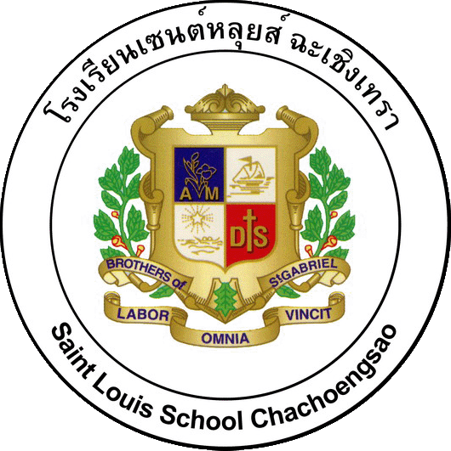



128 Supakit Rd., Muang, Chachoengsao, 24000 THAILAND
Tel: 0-3853-5500, Fax: 0-3853-5501, 0-3853-5487
Homepage: http://www.sl.ac.th E-mail: sl@sl.ac.th

